## Transfer to Another Machine or Computer

In the event of a transfer to another PC, the program will ask the user whether they want to reactivate their account on the new PC.

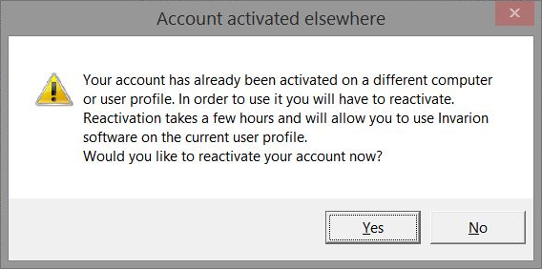

account activated elsewhere

If a user chooses to reactivate their license, it will be disabled while being transferred. Generally, the process takes approximately 8 hours, after which the user will be able to log in as normal.